|  |  |
| --- | --- |
| Lab 2 | |
| ECE 380 W21 | |
| Group 8 | |
| Arjun Bawa, a3bawa | Andrew Tran, a89tran |

Table of Contents

Declaration of Authorship 3

2.1 4

2.2 5

2.3 5

2.4 6

2.5 7

2.6 8

2.7 9

1 9

2 10

3 11

4 12

5 12

6 12

7 13

8 14

# Declaration of Authorship

We acknowledge and promise that:

1. We are the sole authors of this lab report and associated simulation files/code.
2. This work represents our original work.
3. We have not shared detailed analysis or detailed design results, computer code, or Simulink diagrams with any other student.
4. We have not obtained or looked at lab reports from any other current or former student of ECE/SE 380, and we have not let any other student access any part of our lab work.
5. We have completely and unambiguously acknowledged and referenced all persons and aids used to help us with our work.

|  |  |
| --- | --- |
| Student1 Name and Signature:  **Arjun Bawa** | Student2 Name and Signature:  **Andrew Tran** |

# 2.1

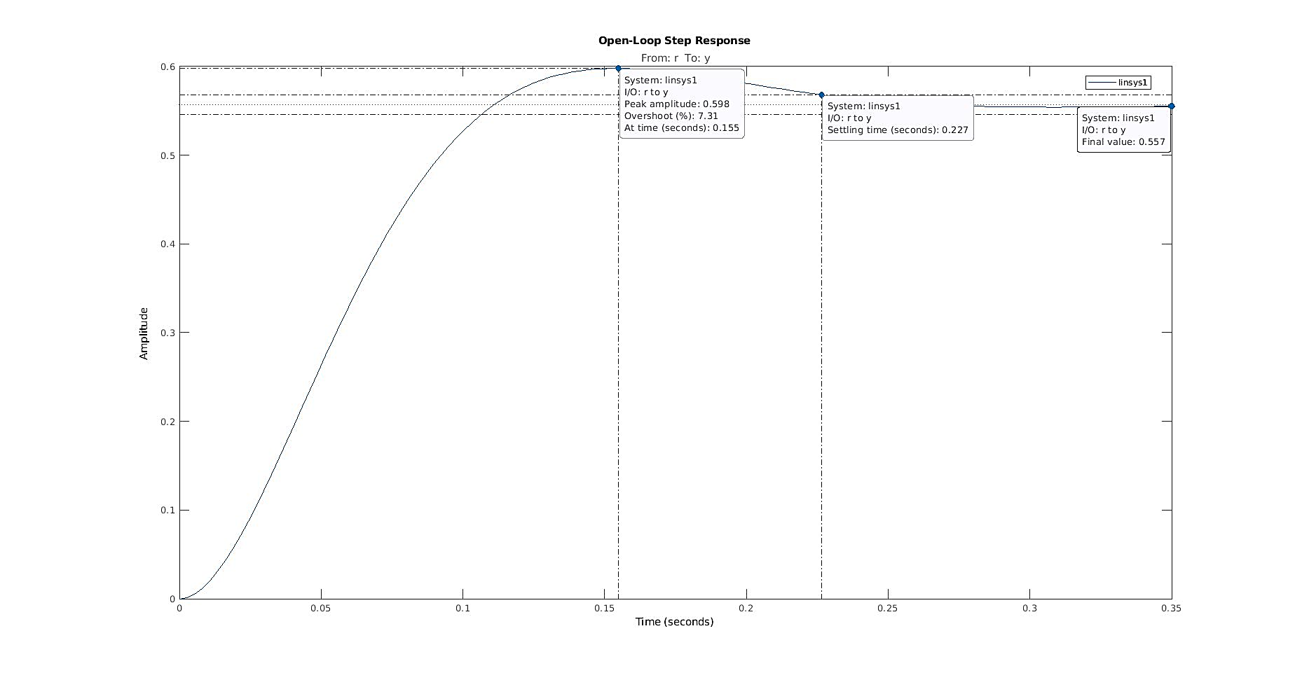

# 2.2

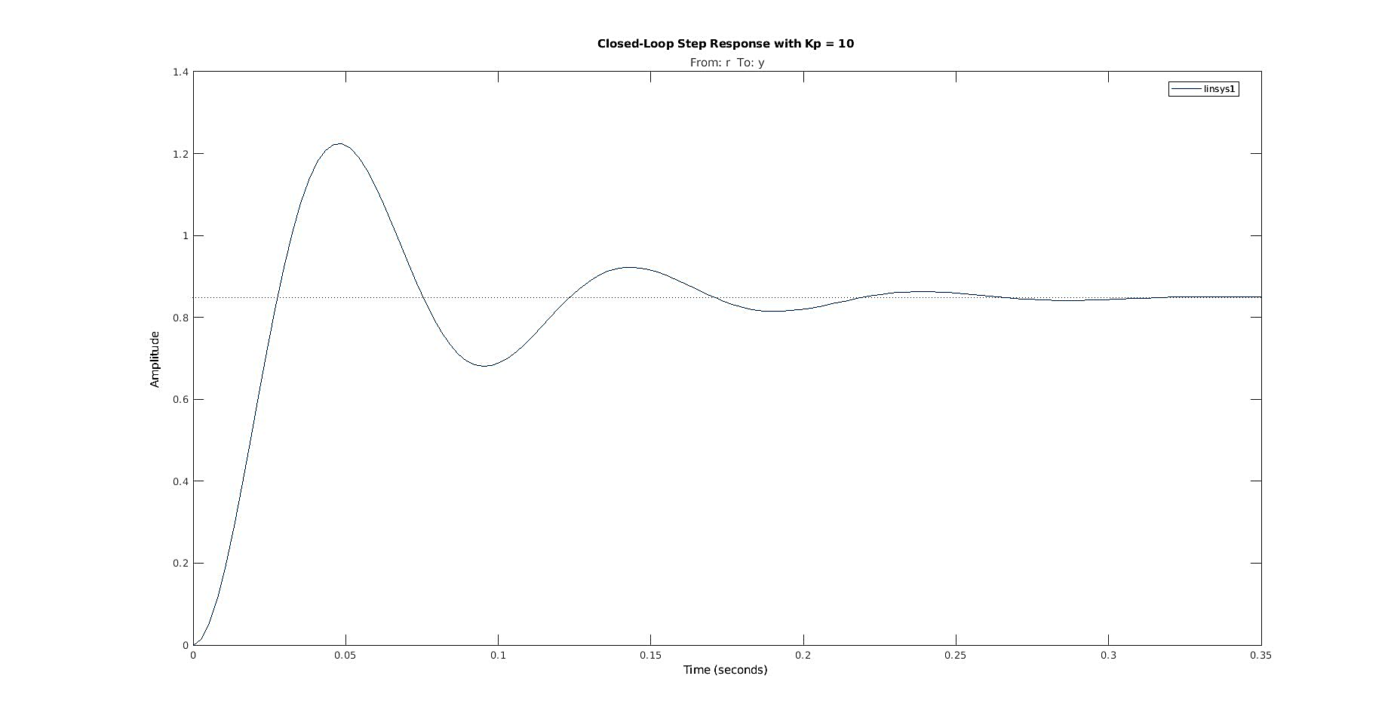

# 2.3

|  |  |  |  |  |
| --- | --- | --- | --- | --- |
| Gain | Steady-State Value | Peak Value | Time-to-Peak | Overshoot |
| 1 | 0.358 | 0.413 | 0.111 seconds | 15.3 % |
| 5 | 0.736 | 0.982 | 0.0652 seconds | 33.5 % |
| 10 | 0.848 | 1.22 | 0.0489 seconds | 44.4 % |

# 2.4

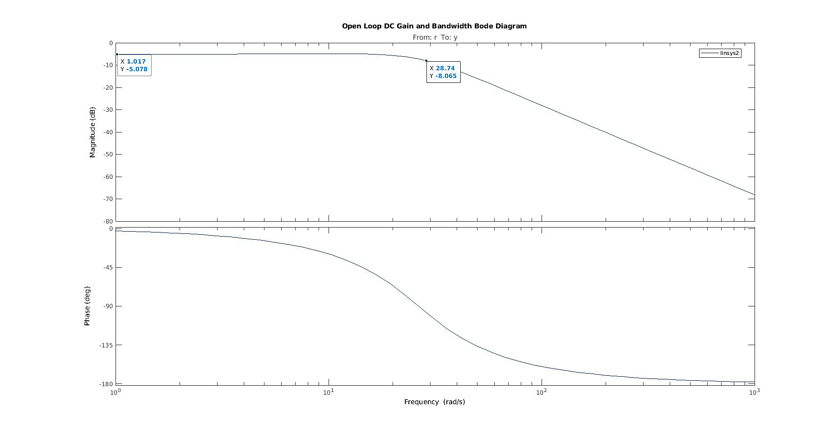

# 2.5

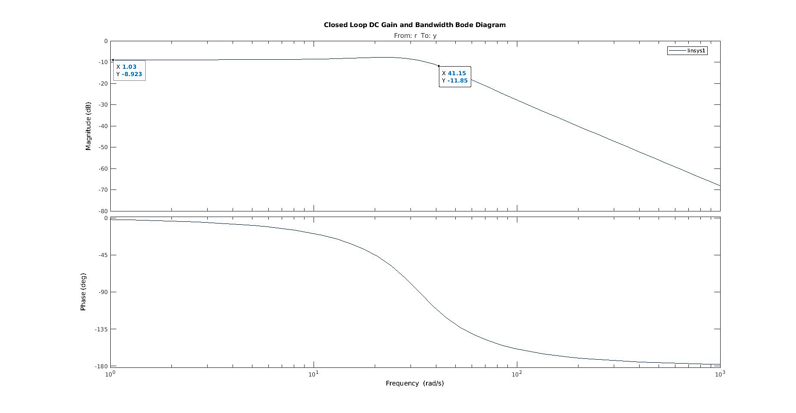

# 2.6

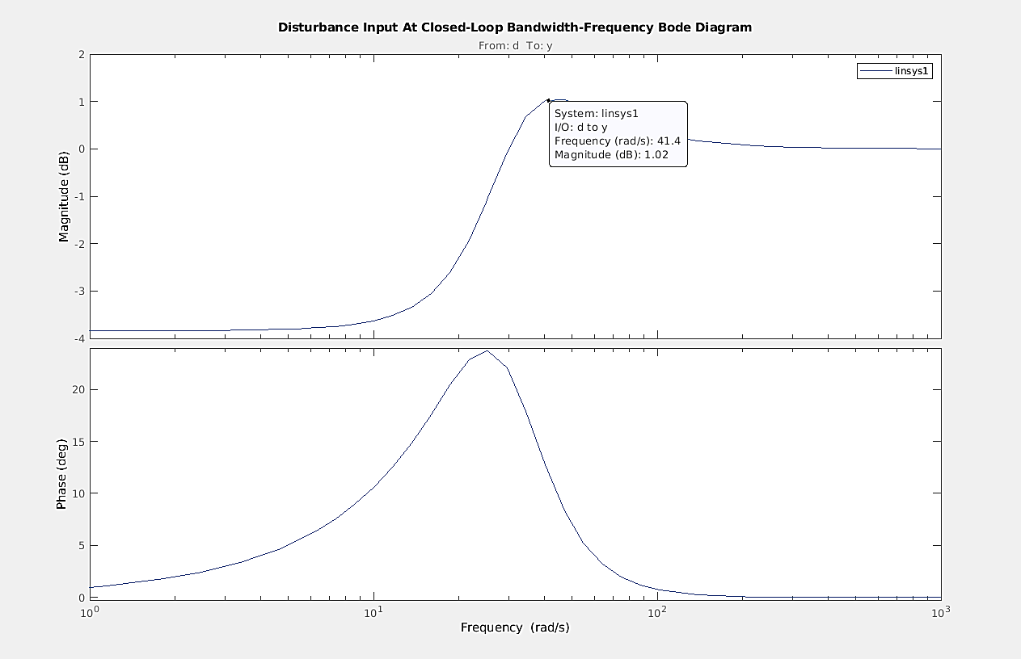

# 2.7

## 1

## 2

## 3

The closed-loop damping ratio , DC gain and natural frequency are given by

|  |  |  |
| --- | --- | --- |
|  |  |  |

Where are open-loop natural frequency, damping ratio and DC gain, respectively.

## 4

Increasing increases the steady-state value , decreases the time-to-peak and increases the percent overshoot of the closed-loop step response.

From the derived equation for above, increasing increases (i.e. increases ), making it approach 1 in the limit.

From the derived equation for above, increasing decreases .

From the formulas in parts 1 and 2, this leads to an increase of because the exponent as decreases. Similarly, as decreases because the denominator as decreases. We see that increases as increases, meaning decreases as increases.

From the approximation in part 1, for the closed-loop 2% settling time. Using the derived equations above, with some substitution we see that . That is, .

This means that theoretically any change in or that a change in causes don’t affect the approximation of 2% settling time. Using some substitution, the closed loop 2% settling time simplifies to which isn’t reliant on any of the closed-loop parameters and thus unaffected by a change in .

## 5

Proportional error feedback control cannot always reliably correct error in the presence of disturbance (which physical systems suffer from). This is because proportional error feedback alone doesn’t consider the possibility that disturbance offsets the error calculated during feedback.

## 6

Going from an open-loop system to a closed-loop system increased the bandwidth frequency from to .

## 7

The closed-loop system rejects disturbance signals well for frequencies well below the closed-loop bandwidth frequency. When disturbance rejection is high, the effect of the disturbance signal on the output is low. This means the magnitude of the disturbance-response transfer function is very small. When disturbance input frequency is small, the plot shows a very small dB value, which indicates a small magnitude of transfer function for small frequencies.

For frequencies approaching the closed-loop bandwidth frequency, disturbance rejection gets worse. The decibel value of the disturbance-response peaks at near the bandwidth frequency before dropping to 0 dB for frequencies higher than the bandwidth. This means that for high frequencies (higher than bandwidth), the effect of the disturbance signal on the output is very significant; the output is almost solely affected by the disturbance signal at high frequencies.

## 8

